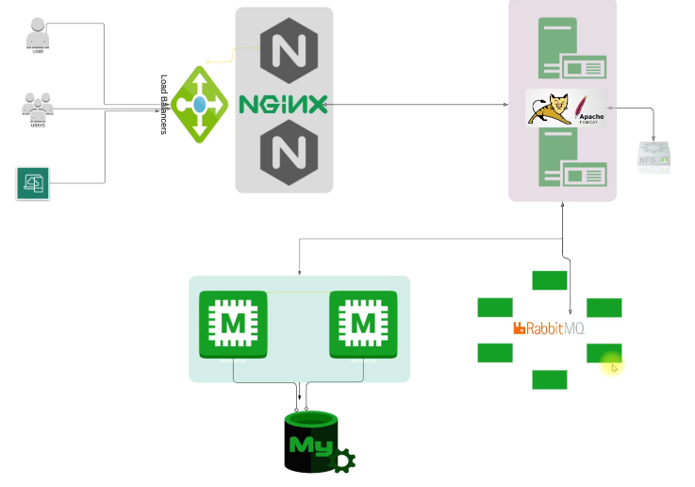

Tomcat: A java web application service. Here the website sits here while the login details stays in mysql

RabbitMQ: A message broker, message queuing agent, an intermediary between Tomcat and the database services

Memcache: A storage caching facility for the database. It saves previous requests and delivers it to the Tomcat service when requested and relieves the database from overwork of processing data

Mysql: Database

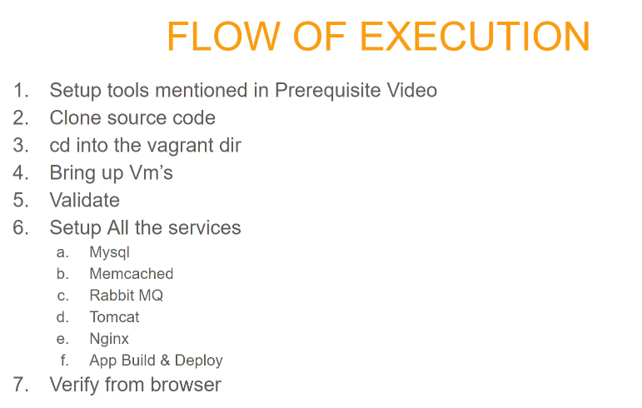

**AUTOMATED CONFIGURATION :**

Steps:

* Open your Vagrant file using Notepad++ and configure it having all services
* Include the script paths:



in all of the Vm’s as shown below:

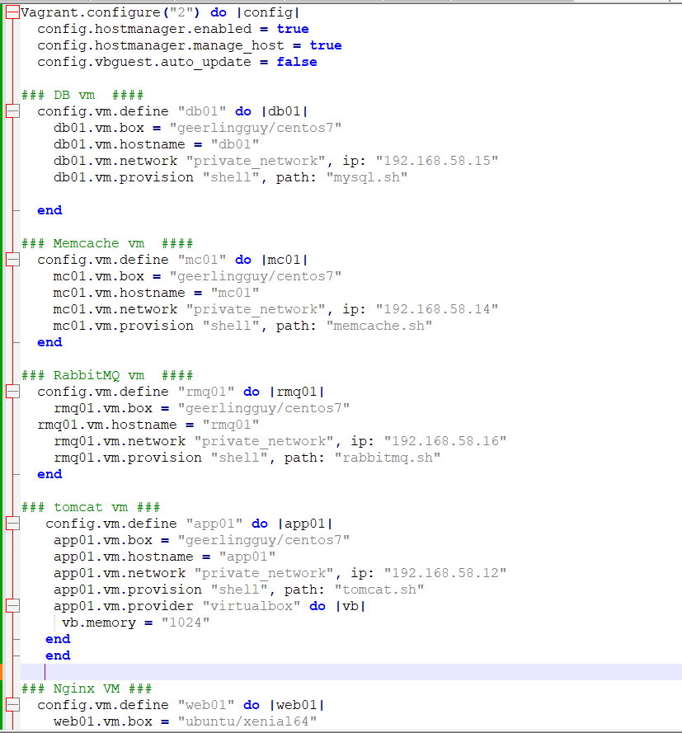

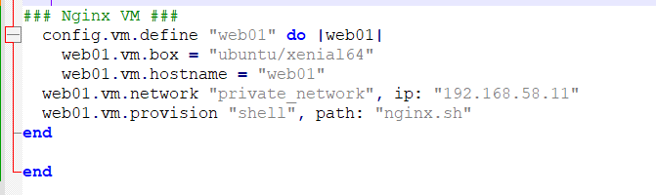

**Write the following scripts:**

mysql 🡺 save as mysql.sh

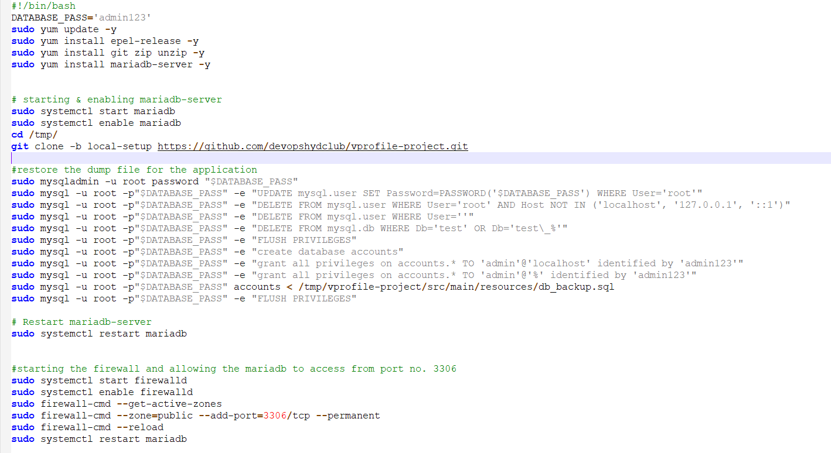

memcache 🡺 save as memcache.sh

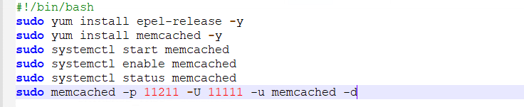

rabbitmq 🡺 save as rabbitmq.sh

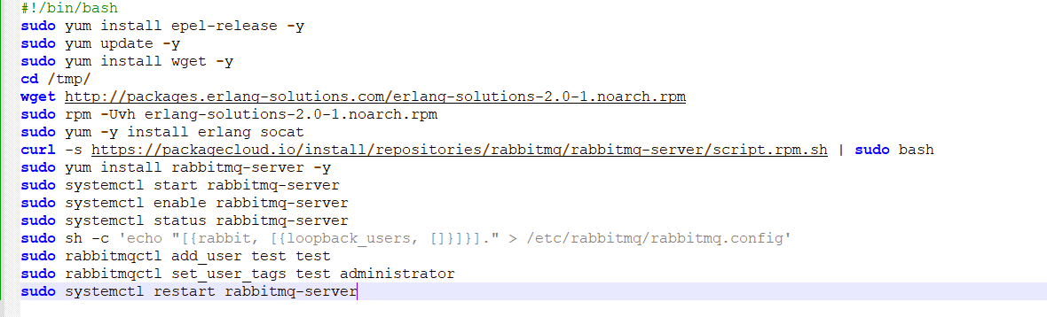

## **tomcat.sh** 🡺 save as **tomcat.sh**

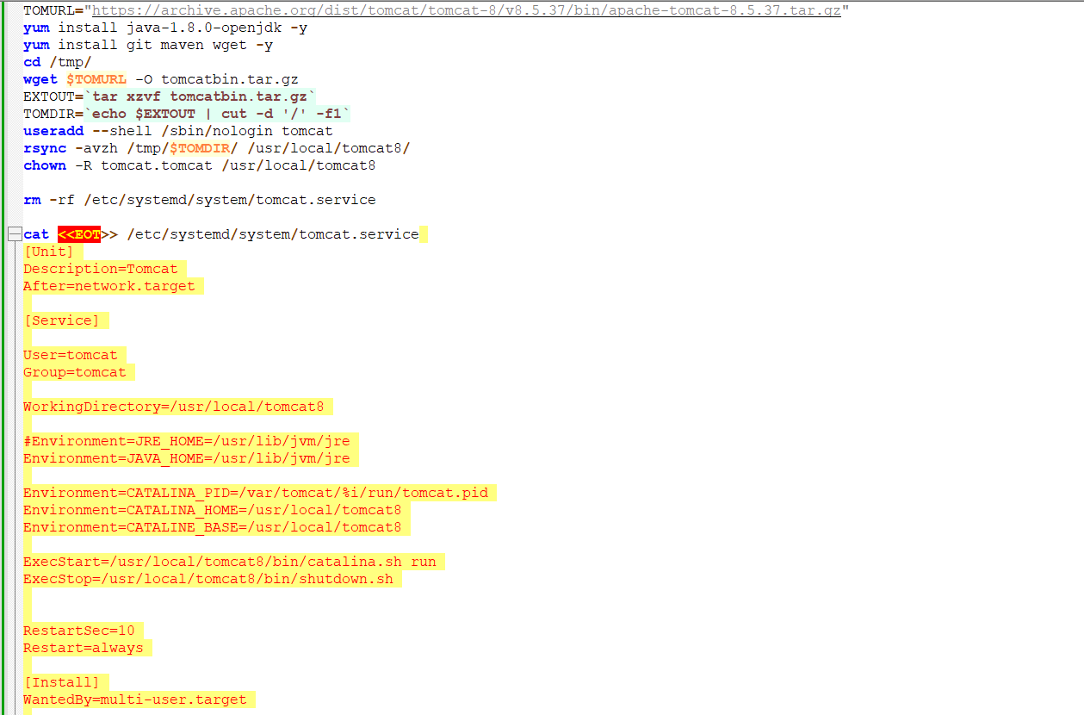

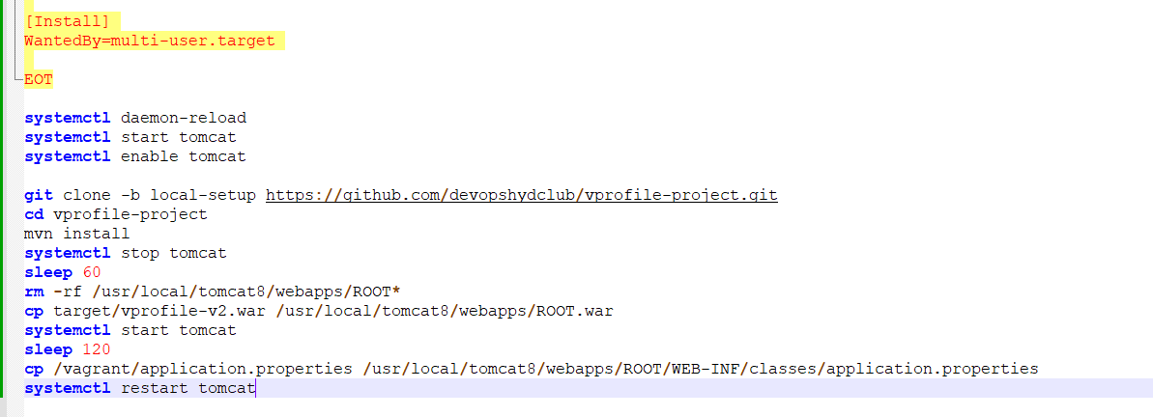

## **Application.properties** 🡺 save as **Application.properties**

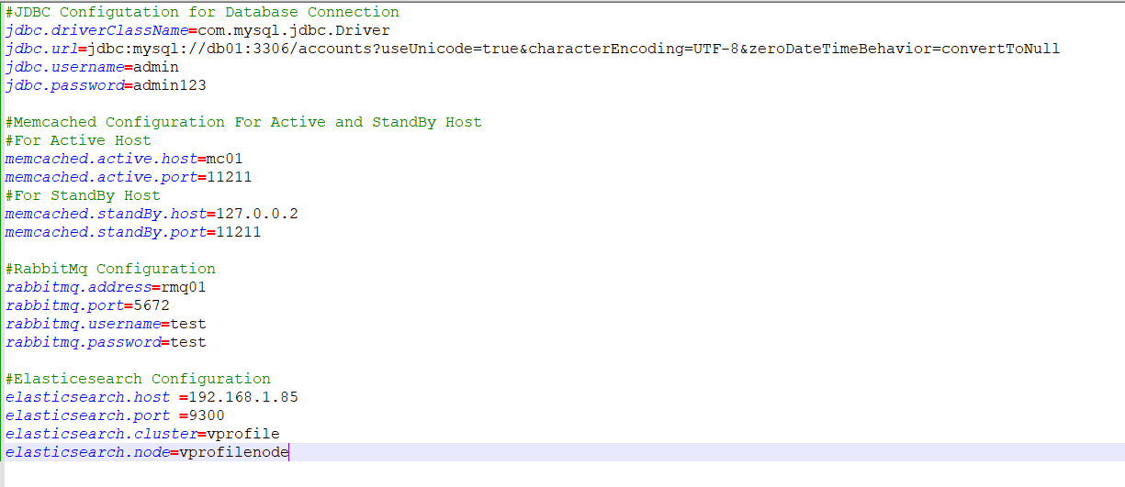

**nginx.sh** 🡺 save as **nginx.sh**

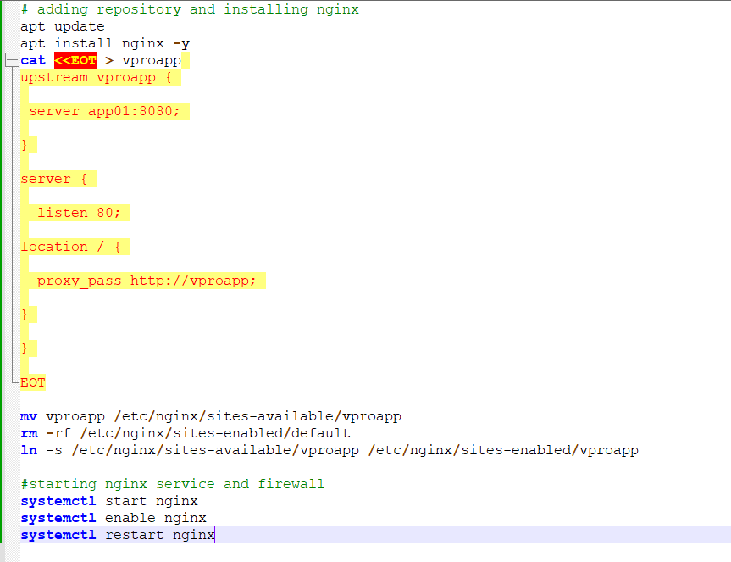

## **backend.sh 🡺 backend.sh**

## 

## 

## **tomcat_ubuntu.sh 🡺 tomcat_ubuntu.sh**

## 

* Go to you gitbash and: vagrant up
* Don’t forget to do the first step of placing the script in your vagrantfile as show above. The scripts will get executed as vagrant starts

Check for the Ip: ifconfig and load in your browser

Username: admin_vp

Password: admin_vp